INS TUBE FLAP CHECKING TOOL GUIDE
- Open SAP and Navigate to Transaction:
  - Go to Transaction ZNBPSTK.
  - Enter your plant code and Execute.
- Select Layout:
  - From the layout options, select the 2nd layout from the top. Make sure data is in the below sequence: - Material > Material Description > Plant > Storage Location > Value > Unrestricted.
- Export to Spreadsheet:
  - Export only by Right-clicking anywhere in the data and choose Export > Spreadsheet.
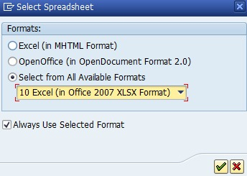
  - Save the file in your desired location when prompted, and it will open automatically.
- Create a New Sheet for Undelivered Stock:
  - In the opened spreadsheet, create a new sheet named "UD" after Sheet1.
  - In the "UD" sheet, starting from cell A1, paste the data for undelivered stock obtained from transaction ZDL. You may sort the Product code and copy below required fields directly from data of ZDL to sheet “UD” in cell A1. Only below 3 columns needed in sheet UD in following respective sequence.
    - Column A: Product code
    - Column B: Product description
    - Column C: Quantity
- Return to Sheet1:
  - After entering the undelivered stock data, go back to Sheet1.
- Use the M R F Tab in Excel:
  - In the "M R F" tab next to the Home tab in Excel, click on the "Stock Taking" icon.
- Execute the Stock Taking Process:
  - The tool will execute the stock-taking programme. Wait for it to complete.
- Finish:
  - Once the process is complete, review the results as needed in auto created worksheet TTF2.

